|  |  |
| --- | --- |
|  | j0319484.wmf  Submitted by -   1. Subodh Verma 2. Hritik Raikwar   Mithi Gobindram Public School IT Project ( Web Development )Get Served – Aab koi tension nahi… |

Acknowledgement

We would like to express our sincere thanks of gratitude to Mr. Brajesh Sir who gave us this opportunity to work on such a wonderful project of WebSite Development. We would also like to extent great thanks to the management of our school who provided us such great facilities.

A great thanks to the Sir Tim Berners-Lee who developed World Wide Web (www) and HTML. Without him the world would have been different. We also thank Mark Dalgleish for his script, without which Parallaxing of backgrounds could not be possible.

Another thanks to all the great personalities and persons involved indirectly with this project.

Thank You

* Subodh Verma
* Hritik Raikwar

( Xth A )

Starting Note

The WebSite in this project contains a lot of hover effects which cannot be represented through pictures. The script used for Parallax ( jquery.stellar.min.js ) is not written by us, the credit goes to Mark Dalgleish for his great work. Bootstrap css ( bootstrap.css ) which an open source script is also not written by us.

To get complete experience of the project visit :

http://beginc.in/getserved

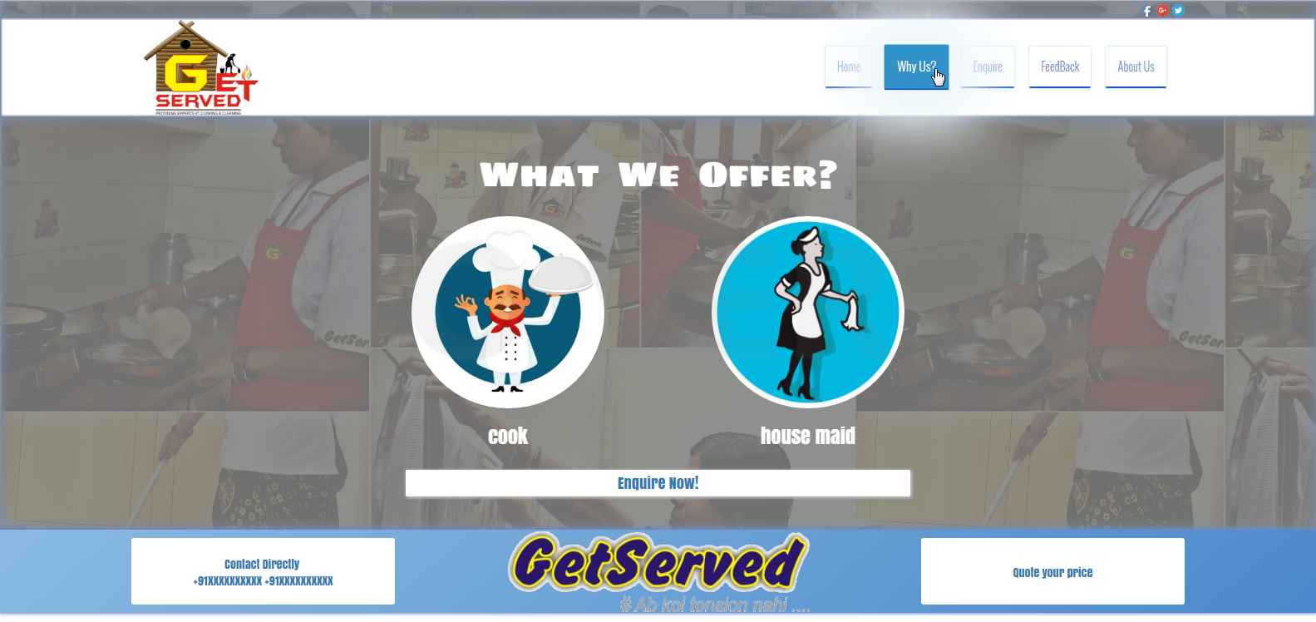

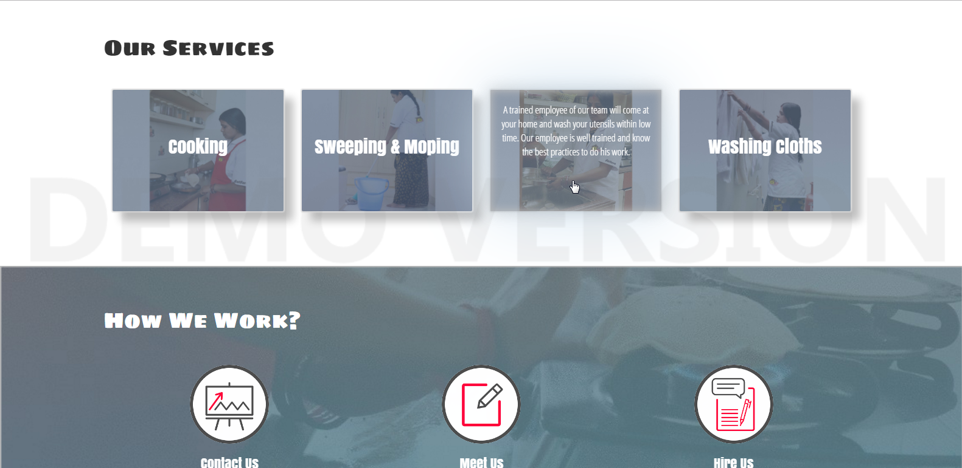

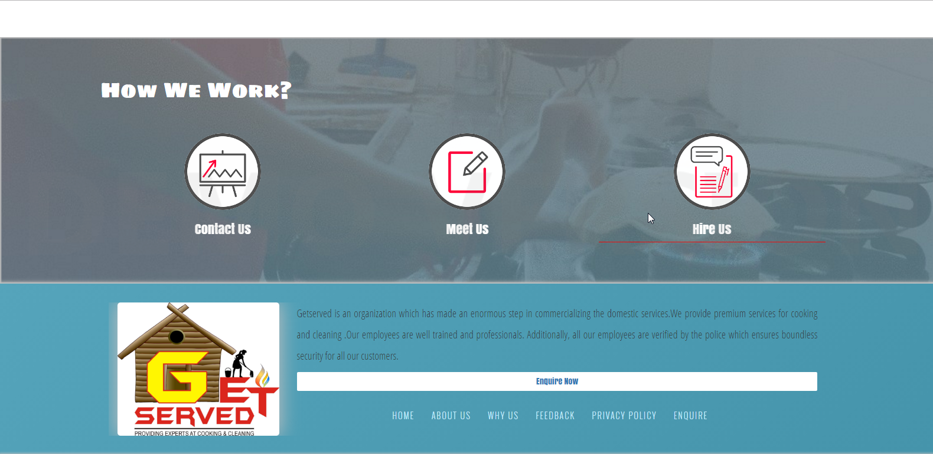

**Index.php**

<!DOCTYPE HTML>

<html>

<head>

<meta charset="utf-8" />

<meta name="viewport" content="width=device-width, initial-scale=1" />

<script src="https://ajax.googleapis.com/ajax/libs/jquery/1.10.2/jquery.min.js">

</script>

<link rel="stylesheet" href="index.css" />

<link rel="stylesheet" href="bootstrap.css" />

<link rel="icon" type="image/gif/png" href="img/s_get-served.jpg" />

<title>Get Served | Ab koi tension nahi...</title>

</head>

<body>

<header>

<div id="Contact-Us_Subodh" >

<div id="Inside-Contact-Us_Subodh">

<a href="#"><img src="Logos/logo_fb.png" height="15px" /></a>

<a href="#"><img src="Logos/logo_g+.png" height="15px" /></a>

<a href="#"><img src="Logos/logo_tw.png" height="15px" /></a>

</div>

</div><!-- Above Contact Us Strip Done -->

<div id="Nav-Div_Subodh">

<div style="margin-left: 10%;margin-right: 10%;height: 120px;">

<div class="col-md-5" style="height:120px;">

<a href="index.php"><img src="img/s_get-served.jpg" height="95%" style="margin-top: 3px;" /></a>

</div>

<div class="col-md-7" id="Nav-Div-Nav_Subodh">

<nav>

<a href="index.php" id="Nav-Home_Subodh"><div>Home</div></a>

<a href="whyus.php"><div>Why Us?</div></a>

<a href="enquire.php"><div>Enquire</div></a>

<a href="feedback.php"><div>FeedBack</div></a>

<a href="aboutus.php"><div>About Us</div></a>

</nav>

</div>

</div>

</div>

</header>

<div data-stellar-background-ratio="0.5" id="What-We-Offer_Subodh" class="container-fluid">

<div style="margin-right: 10%;margin-left: 10%;overflow:hidden;">

<div id="What-We-Offer-Box_Subodh">

<div><h1><span class="animated fadeInLeft">What&nbsp; W</span><span class="animated fadeInRight">e&nbsp; Offer?</span></h1></div>

<br />

<div id="What-We-Offer-Content_Subodh">

<div id="What-We-Offer-Content-Box_Subodh" class="col-md-6 col-sm-6 col-xs-6" style="padding-right: 5%; padding-left: 5%;">

<div>

<img src="img/cook.jpg" width="80%" class="What-We-Offer-Img_Subodh animated fadeInUp" />

</div>

<h3 class="animated fadeInLeft">

cook

</h3>

</div>

<div id="What-We-Offer-Content-Box_Subodh" class="col-md-6 col-sm-6 col-xs-6" style="padding-left: 5%; padding-right: 5%;">

<div>

<img src="img/maid.jpg" width="80%" class="What-We-Offer-Img_Subodh animated fadeInUp" />

</div>

<h3 class="animated fadeInRight">

house maid

</h3>

</div>

</div>

</div>

<br />

</div>

<div style="margin-left:30%; margin-right: 30%;">

<a href="enquire.php">

<div class="Enquire-Button-0_Subodh">

<p style="margin: 0;">Enquire Now!</p>

</div>

</a>

</div>

</div>

<br />

<!-- What We Offer End -->

<div id="Estimator-Outer_Subodh">

<div id="Estimator_Subodh">

<a href="enquire.php">

<div class="col-md-3 Estimator-blocks_Subodh Estimator-blocks-tile_Subodh estimate1">

<p>Contact Directly <br /> +91XXXXXXXXXX +91XXXXXXXXXX</p>

</div>

</a>

<a href="index.php">

<div class="col-md-6 Estimator-blocks_Subodh Estimator-blocks-Img_Subodh">

<img src="img/h_get-served.png" height="98px" style="margin-top: 1px;border-radius: 2px;" />

</div>

</a>

<a href="enquire.php">

<div class="col-md-3 Estimator-blocks_Subodh Estimator-blocks-tile_Subodh estimate2" style="line-height: 2.9;">

<p>Quote your price</p>

</div>

</a>

</div>

</div>

<div id="Our-Services_Subodh" style="z-index: 1;" class="container-fluid">

<div style="margin-left:10%;margin-right: 10%;margin-top: 20px;">

<div><h1 style="font-family: 'Sigmar One';" class="animated fadeInBig">Our Services</h1></div><br /><br />

<div id="Outer-Blocks-Our-Services_Subodh">

<div class="col-lg-3 col-md-6 col-sm-6 col-xs-12">

<div class="blocks blocks1 animated fadeInLeft fadeInBig">

<div class="head1"><h2>Cooking</h2></div>

<div class="Hidden-Block1_Subodh"><p>

<p>

We have a team of professionally trained women employees. Our employee can cook mulltiple cuisine and daily

food, all you need is just to tell her the food you want to have and rest she will figure it out.

</p>

</p></div>

</div>

</div>

<div class="col-lg-3 col-md-6 col-sm-6 col-xs-12">

<div class="blocks blocks2 animated fadeInLeft">

<div class="head2"><h2>Sweeping & Moping</h2></div>

<div class="Hidden-Block2_Subodh"><p>

<p>

Our team of 3 members will come at your place and will sweep and mop your entire house within 15 to 20 minutes.

</p>

</p></div>

</div>

</div>

<div class="col-lg-3 col-md-6 col-sm-6 col-xs-12">

<div class="blocks blocks3 animated fadeInRight">

<div class="head3"><h2>Washing Utensils</h2></div>

<div class="Hidden-Block3_Subodh"><p>

<p>

A trained employee of our team will come at your home and wash your utensils within low time.

Our employee is well trained and know the best practices to do his work.

</p>

</p></div>

</div>

</div>

<div class="col-lg-3 col-md-6 col-sm-6 col-xs-12">

<div class="blocks blocks4 animated fadeInRight fadeInBig">

<div class="head4"><h2>Washing Cloths</h2></div>

<div class="Hidden-Block4_Subodh"><p>

<p>

A well trained employee of our team will come to your house and wash all your dirty clothes within

low time. Additionally, our employee exactly knows the amount of detergent and soap required

to wash certain number of clothes.

</p>

</p></div>

</div>

</div>

</div>

</div>

</div>

<!-- Our Services End -->

<section data-stellar-background-ratio="0.5" class="container-fluid" style="overflow: hidden;background-image: url('img/back-cook.jpg');background-position: center;background-size: 110%;padding-top: 70px;padding-bottom: 70px;box-shadow: 0px 0px 2px 2px silver inset;">

<div id="How-We-Work_Subodh">

<div>

<h1 style="font-family: 'Sigmar One';color: white;">

How We Work?

</h1>

</div>

<div style="text-align: center;">

<div id="How-We-Work-Content_Subodh">

<div class="How-We-Work-Blocks_Subodh col-sm-4 col-xs-12 animated fadeInUp">

<div class="How-We-Work-Blocks-Img_Subodh">

<img src="img/contact-us.png" height="130px" width="130px" />

</div>

<div>

<h3>

Contact Us

</h3>

</div><div class="Hover_Subodh"></div>

</div>

<div class="How-We-Work-Blocks_Subodh col-sm-4 col-xs-12 animated fadeInUp">

<div class="How-We-Work-Blocks-Img_Subodh">

<img src="img/meet-us.png" height="130px" width="130px" />

</div>

<div>

<h3>

Meet Us

</h3>

</div><div class="Hover_Subodh"></div>

</div>

<div class="How-We-Work-Blocks_Subodh col-sm-4 animated fadeInUp">

<div class="How-We-Work-Blocks-Img_Subodh">

<img src="img/hire-us.png" height="130px" width="130px" />

</div>

<div>

<h3>

Hire Us

</h3>

</div><div class="Hover_Subodh"></div>

</div>

</div>

</div>

</div>

</section>

<div id="Footer-Outer_Subodh">

<div id="Footer_Subodh">

<div>

<div class="col-md-3 Footer-Division_Subodh" style="text-align: center;">

<a href="index.php"><img src="img/s_get-served.jpg" width="100%" style="border-radius: 5px;box-shadow: 0px 0px 50px 2px silver ;" id="Footer-img_Subodh" /></a>

</div>

<div class="col-md-9 Footer-Division_Subodh">

<div>

<p>

Getserved is an organization which has made an enormous step in commercializing

the domestic services.We provide premium services for cooking and cleaning

.Our employees are well trained and professionals. Additionally, all our employees

are verified by the police which ensures boundless security for all our customers.

</p>

<a href="enquire.php">

<div class="Enquire-Button_Subodh">

Enquire Now

</div>

</a>

</div>

<ul>

<li><a href="index.php">HOME</a></li> &nbsp;&nbsp;&nbsp;&nbsp;

<li><a href="aboutus.php">ABOUT US</a></li> &nbsp;&nbsp;&nbsp;&nbsp;

<li><a href="whyus.php">WHY US</a></li> &nbsp;&nbsp;&nbsp;&nbsp;

<li><a href="feedback.php">FEEDBACK </a></li> &nbsp;&nbsp;&nbsp;&nbsp;

<li><a href="#">PRIVACY POLICY</a></li> &nbsp;&nbsp;&nbsp;&nbsp;

<li><a href="enquire.php">ENQUIRE</a></li> &nbsp;&nbsp;&nbsp;&nbsp;

</ul>

</div>

</div>

</div>

</div>

<script src="jquery.stellar.min.js"></script>

<script>

$.stellar();

</script>

</body>

</html>

**index.css**

@font-face {

font-family: 'Open Sans Condensed';

font-style: normal;

font-weight: 300;

src: local('Open Sans Cond Light'), local('OpenSans-CondensedLight'), url(https://fonts.gstatic.com/s/opensanscondensed/v10/gk5FxslNkTTHtojXrkp-xBEur64QvLD-0IbiAdTUNXE.woff2) format('woff2');

unicode-range: U+0000-00FF, U+0131, U+0152-0153, U+02C6, U+02DA, U+02DC, U+2000-206F, U+2074, U+20AC, U+2212, U+2215, U+E0FF, U+EFFD, U+F000;

}

@font-face {

font-family: 'Oswald';

font-style: normal;

font-weight: 400;

src: local('Oswald Light'), local('Oswald-Light'), url(https://fonts.gstatic.com/s/oswald/v11/HqHm7BVC_nzzTui2lzQTDVtXRa8TVwTICgirnJhmVJw.woff2) format('woff2');

unicode-range: U+0000-00FF, U+0131, U+0152-0153, U+02C6, U+02DA, U+02DC, U+2000-206F, U+2074, U+20AC, U+2212, U+2215, U+E0FF, U+EFFD, U+F000;

}

@font-face {

font-family: 'Sigmar One';

font-style: normal;

font-weight: 400;

src: local('Sigmar One'), local('SigmarOne'), url(http://fonts.gstatic.com/s/sigmarone/v6/aRAZJs6CY7SV6eSg6Wx4j_k_vArhqVIZ0nv9q090hN8.woff2) format('woff2');

unicode-range: U+0000-00FF, U+0131, U+0152-0153, U+02C6, U+02DA, U+02DC, U+2000-206F, U+2074, U+20AC, U+2212, U+2215, U+E0FF, U+EFFD, U+F000;

}

@font-face {

font-family: 'Anton';

font-style: normal;

font-weight: 400;

src: local('Anton'), url(http://fonts.gstatic.com/s/anton/v7/o-91-t7-bPc7W26HmS2N4Q.woff2) format('woff2');

unicode-range: U+0000-00FF, U+0131, U+0152-0153, U+02C6, U+02DA, U+02DC, U+2000-206F, U+2074, U+20AC, U+2212, U+2215, U+E0FF, U+EFFD, U+F000;

}

.animated {

-webkit-animation-duration: 2s;

animation-duration: 2s;

-webkit-animation-fill-mode: both;

animation-fill-mode: both;

}

@-webkit-keyframes fadeInUp {

from{opacity: 0;

-webkit-transform: translate3d(0, 100%, 0);

transform: translate3d(0, 100%, 0);}

to{opacity: 1;-webkit-transform: none;

transform: none;}

}

@keyframes fadeInUp {

from {opacity: 0;-webkit-transform: translate3d(0, 100%, 0);

transform: translate3d(0, 100%, 0);}

to {opacity: 1;-webkit-transform: none;

transform: none;}

}

.fadeInUp {

-webkit-animation-name: fadeInUp;

animation-name: fadeInUp;

}

@-webkit-keyframes fadeInLeft {

0% {

opacity: 0;

-webkit-transform: translate3d(-200px,0,0);

}

100% {

opacity: 1;

-webkit-transform: none;

}

}

@keyframes fadeInLeft {

0% {

opacity: 0;

transform: translate3d(-200px,0,0);

}

100% {

opacity: 1;

transform: none;

}

}

.fadeInLeft {

-webkit-animation-name: fadeInLeft;

animation-name: fadeInLeft;

}

@-webkit-keyframes fadeInRight {

0% {

opacity: 0;

-webkit-transform: translate3d(200px,0,0);

}

100% {

opacity: 1;

-webkit-transform: none;

}

}

@keyframes fadeInRight {

0% {

opacity: 0;

transform: translate3d(200px,0,0);

}

100% {

opacity: 1;

transform: none;

}

}

.fadeInRight {

-webkit-animation-name: fadeInRight;

animation-name: fadeInRight;

}

@-webkit-keyframes fadeInRight1 {

0% {

opacity: 0;

-webkit-transform: translate3d(600px,0,0);

}

100% {

opacity: 1;

-webkit-transform: none;

}

}

@keyframes fadeInRight1 {

0% {

opacity: 0;

transform: translate3d(600px,0,0);

}

100% {

opacity: 1;

transform: none;

}

}

.fadeInRight {

-webkit-animation-name: fadeInRight1;

animation-name: fadeInRight1;

}

@-webkit-keyframes fadeInBig {

0% {

opacity: 0;

-webkit-transform: scale(2,2);

}

100% {

opacity: 1;

-webkit-transform: none;

}

}

@keyframes fadeInBig {

0% {

opacity: 0;

transform: scale(2,2);

}

100% {

opacity: 1;

transform: none;

}

}

.fadeInBig {

-webkit-animation-name: fadeInBig;

animation-name: fadeInBig;

}

#Contact-Us_Subodh {

background-color: #518ED2;

background-image: url('img/back_para_img3.jpg');

text-align:right;

background-size: 65%;

box-shadow: 0px 0px 20px 2px #7A8CA7 inset;

}

#Inside-Contact-Us_Subodh {

padding-left: 10%;

padding-right: 10%;

}

#Inside-Contact-Us_Subodh img {

border-radius: 50%;

}

#Nav-Div_Subodh {

height: 120px;

box-shadow: 0px 0px 2px 2px #449CD0;

box-shadow: 0px 0px 2px 2px #7A8CA7 inset;

text-shadow: 0.5px 0.5px 1px 1px rgba(50,50,200,1);

}

#Nav-Div-Nav_Subodh {

height: 120px;

text-align: right;

}

nav {

height:100%;

padding-top: 35px;

}

nav div {

display: inline-block;

padding: 2%;

margin-left: 1%;

margin-right: 1%;

color: #518ED2;

border-radius: 2px;

border-bottom: 2px solid #1658C7;

transition-duration: 0.4s;

box-shadow: 0px 0px 1px 1px #CFEDEF;

font-family: 'Oswald';

}

nav div:hover {

background-color: #3392CA;

box-shadow: 0px 2px 100px 40px #EEF7FB;

transform: scale(1.1,1.1);

color: white;

}

@media all and (max-width:1380px){

#Nav-Home_Subodh {

display: none;

}

}

@media all and (max-width:1050px){

#Nav-Home_Subodh div {

display: none;

}

}

@media all and (max-width:992px){

#Nav-Div_Subodh {

height: 240px;

text-align: center;

}

#Nav-Div-Nav_Subodh {

height: 240px;

text-align: center;

padding: 0;

}

}

/* Header End */

#What-We-Offer_Subodh {

width: 100%;

background-image: url('img/back_para_img3.jpg');

background-attachment: fixed;

background-size: 65%;

color: white;

box-shadow: 0px 0px 20px 2px #7A8CA7 inset;

padding: 2%;

padding-top: 40px;

padding-bottom: 40px;

}

#What-We-Offer-Box_Subodh {

padding: 0.5%;

text-align: center;

width: 100%;

}

#What-We-Offer-Box_Subodh h1 {

font-family:'Sigmar One';

font-size: 3em;

margin-top: auto;

margin-bottom: auto;

padding-top: 0;

text-shadow: 4px 4px 20px 20px black;

}

#What-We-Offer-Content_Subodh {

margin-right: 20%;

margin-left: 20%;

}

#What-We-Offer-Content-Box_Subodh {

display: inline-block;

padding: 1%;

text-align: center;

transition-duration: 0.2s;

}

#What-We-Offer-Content-Box_Subodh div {

height: 20%;

}

#What-We-Offer-Content-Box_Subodh:hover {

border-radius: 30px;

cursor: pointer;

}

.What-We-Offer-Img_Subodh {

transition-duration: 0.4s;

border-radius: 50%;

}

#What-We-Offer-Content-Box_Subodh:hover .What-We-Offer-Img_Subodh {

transform: scale(0.9,0.9);

box-shadow: 0px 0px 20px 2px silver;

}

#What-We-Offer-Content-Box_Subodh:hover h3 {

transform: scale(1.3,1.3);

}

h3 {

transition-duration: 0.2s;

}

#What-We-Offer-Content-Box_Subodh h3 {

font-family: 'Anton';

}

.Enquire-Button-0_Subodh {

background-color: white;

border-radius: 2px;

text-align: center;

margin-top: 10px;

font-family: 'Anton';

padding: 3.5px;

transition-duration: 0.2s;

font-size: 130%;

text-decoration: none;

box-shadow: 1px 1px 4px 1px silver;

}

.Enquire-Button-0_Subodh:hover {

background: #037DB8;

color: white;

box-shadow: 0px 0px 20px 1px silver;

}

/* What we offer end */

#Estimator-Outer_Subodh {

background: -webkit-linear-gradient(140deg,#8ABAE1 , #4B88CB);

background: -o-linear-gradient(140deg,#8ABAE1 , #4B88CB);

background: -moz-linear-gradient(140deg,#8ABAE1 , #4B88CB);

background: linear-gradient(140deg,#8ABAE1 , #4B88CB );

background-color: #8ABAE1;

height: 100px;

box-shadow: 0px 0px 5px 1px #7186CE;

margin-top: -20px;

}

#Estimator_Subodh {

margin-right: 10%;

margin-left: 10%;

font-family: 'Anton';

text-align: center;

height: 100px;

}

#Estimator_Subodh a {

height: 100px;

}

#Estimator_Subodh p {

margin-top: 10px;

}

.Estimator-blocks_Subodh {

display: inline-block;

text-align: center;

}

.Estimator-blocks-tile_Subodh {

background-color: white;

border-radius: 3px;

height: 80px;

margin-top: 10px;

padding: 1%;

transition-duration: 0.35s;

}

.Estimator-blocks-tile_Subodh:hover {

box-shadow: 0px 0px 10px 2px silver;

transform: scale(1.1,1.02);

}

@media all and (max-width:995px){

.Estimator-blocks-Img_Subodh {

display: none;

}

.Estimator-blocks-tile_Subodh {

width: 45%;

margin-top: 2.8%;

}

.estimate1 {

float: left;

}

.estimate2 {

float: right;

}

}

#Our-Services_Subodh {

overflow: hidden;

padding-top: 60px;

padding-bottom: 90px;

}

#Outer-Blocks-Our-Services_Subodh {

text-align: center;

}

.blocks {

background-color: #92ABD1;

border-radius: 2px;

padding: 4%;

height: 200px;

cursor: pointer;

box-shadow: 0px 0px 2px 2px #DFDFDF, 15px 15px 20px 1px silver;

color: black;

transition-duration: 0.5s;

background-position: center;

background-size: 110%;

color: white;

}

.blocks:hover {

box-shadow: 0px 0px 200px 3px #D1E3F1 , 0px 0px 40px 1px silver , 0px 0px 20px 1.5px silver inset , 0px 0px 2px 2px #DFDFDF;

background-size: 130%;

transform: scale(1.3,1.08);

}

@media all and (max-width: 1199px){

.blocks {

margin-top: 20px;

}

}

@media all and (max-width: 550px){

.blocks h2 {

font-size: 140%;

}

.head1 {

margin-top: 0px;

}

.head2 {

margin-top: 0px;

}

.head3 {

margin-top: 0px;

}

.head4 {

margin-top: 0px;

}

.Hidden-Block1_Subodh {

display: block;

}

#What-We-Offer-Box_Subodh h1 {

font-size: 190%;

}

}

@media all and (max-width: 992px){

.blocks {

margin-top: 20px;

}

#What-We-Offer-Content_Subodh {

margin-right: 10%;

margin-left: 10%;

}

#Footer-img_Subodh {

width: 40%;

}

}

@media all and (max-width: 768px){

.blocks {

margin-top: 20px;

}

#What-We-Offer-Content_Subodh {

margin-right: 0;

margin-left: 0;

}

}

@media all and (max-width: 670px){

.blocks {

font-size: 90%;

}

}

@-webkit-keyframes fadeIn {

0% { opacity: 0; }

20% { opacity: 0; }

40% { opacity: 0.3; }

60% { opacity: 0.5; }

80% { opacity: 0.9; }

100% { opacity: 1; }

}

@keyframes fadeIn {

0% { opacity: 0; }

20% { opacity: 0; }

40% { opacity: 0.3; }

60% { opacity: 0.5; }

80% { opacity: 0.9; }

100% { opacity: 1; }

}

.blocks1 {

background-image: url('img/services/03.jpg');

}

.head1 {

font-family:'Anton';

transition-duration: 1s;

margin-top: 65px;

}

.blocks1:hover .head1 {

display: none;

font-weight: bold;

}

.blocks1:hover .Hidden-Block1_Subodh{

display: block;

-webkit-animation-name: fadeIn;

-webkit-animation-duration: 0.5s;

animation-name: fadeIn;

animation-duration: 0.5s;

}

.Hidden-Block1_Subodh {

display: none;

transition-duration: 1s;

font-family: 'Open Sans Condensed';

font-size: 120%;

}

.blocks2 {

background-image: url('img/services/02.jpg');

}

.head2 {

font-family:'Anton';

transition-duration: 0.2s;

margin-top: 65px;

}

.blocks2:hover .head2 {

display: none;

}

.blocks2:hover .Hidden-Block2_Subodh{

display: block;

-webkit-animation-name: fadeIn;

-webkit-animation-duration: 0.5s;

animation-name: fadeIn;

animation-duration: 0.5s;

}

.Hidden-Block2_Subodh {

display: none;

transition-duration: 0.2s;

font-family: 'Open Sans Condensed';

font-size: 120%;

}

.blocks3 {

background-image: url('img/services/06.jpg');

}

.head3 {

font-family:'Anton';

transition-duration: 0.2s;

margin-top: 65px;

}

.blocks3:hover .head3 {

display: none;

}

.blocks3:hover .Hidden-Block3_Subodh{

display: block;

-webkit-animation-name: fadeIn;

-webkit-animation-duration: 0.5s;

animation-name: fadeIn;

animation-duration: 0.5s;

}

.Hidden-Block3_Subodh {

display: none;

transition-duration: 0.2s;

font-family: 'Open Sans Condensed';

font-size: 120%;

}

.blocks4 {

background-image: url('img/services/05.jpg');

}

.head4 {

font-family:'Anton';

transition-duration: 0.2s;

margin-top: 65px;

}

.blocks4:hover .head4 {

display: none;

}

.blocks4:hover .Hidden-Block4_Subodh{

display: block;

-webkit-animation-name: fadeIn;

-webkit-animation-duration: 0.5s;

animation-name: fadeIn;

animation-duration: 0.5s;

}

.Hidden-Block4_Subodh {

display: none;

transition-duration: 0.2s;

font-family: 'Open Sans Condensed';

font-size: 120%;

}

/*Our Services End*/

#How-We-Work_Subodh {

margin-right: 10%;

margin-left: 10%;

}

#How-We-Work_Subodh h1 {

margin: 0;

}

#How-We-Work-Content_Subodh {

margin-top: 30px;

}

.How-We-Work-Blocks_Subodh {

display: inline-block;

padding: 2% 2% 0 2%;

margin-right: auto;

margin-left: auto;

text-align: center;

}

.How-We-Work-Blocks_Subodh h3 {

font-family: 'Anton';

font-size: 160%;

color: white;

}

.How-We-Work-Blocks-Img_Subodh img {

border-radius: 100%;

}

.Hover_Subodh {

height: 1px;

width: 0px;

background-color: red;

transition-duration: 0.5s;

}

.How-We-Work-Blocks_Subodh:hover .Hover_Subodh {

width: 100%;

}

/* Foooooooter */

#Footer-Outer_Subodh{

padding: 2%;

margin-bottom: 0px;

overflow: hidden;

line-height: 2;

background: -webkit-linear-gradient(140deg, #55A4BB, #4594AB);

background: -o-linear-gradient(140deg, #55A4BB, #4594AB);

background: -moz-linear-gradient(140deg, #55A4BB, #4594AB);

background: linear-gradient(140deg, #55A4BB, #4594AB);

box-shadow: 0px 0px 10px 2px silver;

}

#Footer_Subodh {

margin-left: 10%;

margin-right: 10%;

text-align: justify;

overflow: hidden;

}

.Enquire-Button_Subodh {

background-color: white;

border-radius: 2px;

text-align: center;

margin-top: 10px;

font-family: 'Anton';

padding: 2px;

transition-duration: 0.2s;

}

.Enquire-Button_Subodh:hover {

background: #037DB8;

color: white;

}

.Enquire-Button_Subodh a{

text-decoration: none;

}

.Footer-Division_Subodh p {

font-family: 'Open Sans Condensed';

font-size: 1.3em;

}

.Footer-Division_Subodh ul {

list-style-type: none;

font-family: 'Oswald';

text-align:center;

padding: 0px;

letter-spacing: 2px;

color: #C7ECFE;

margin-top: 3%;

}

.Footer-Division_Subodh ul li {

display: inline-block;

margin-top: 2px;

}

.Footer-Division_Subodh ul a{

color: #C7ECFE;

}

.Designer {

text-align: right;

background: -webkit-linear-gradient(0deg, #079BE2, #22B3F9 );

background: -o-linear-gradient(0deg, #079BE2, #22B3F9 );

background: -moz-linear-gradient(0deg, #079BE2, #22B3F9 );

background: linear-gradient(0deg, #079BE2, #22B3F9 );

padding: 0.3%;

color: white;

font-family: 'Open Sans Condensed';

box-shadow: 0px 0px 5px 2px silver;

}

@media all and (max-width: 500px){

.Enquire-Button_Subodh {

margin-bottom: 10px;

}

#Footer-Outer_Subodh {

line-height: 1.6;

}

#Footer_Subodh {

margin-left: 1%;

margin-right: 1%;

}

.Why-Us-Blocks_Subodh {

font-size: 75%;

}

.About-Us-Content_Subodh {

margin-left: 8%;

margin-right: 8%;

}

}

/************************************WhyUS**********************************/

.Why-Us-Parallax_Subodh {

width: 100%;

padding: 5%;

overflow: hidden;

text-align: center;

background-image: url('img/services/06-0.jpg');

font-family: 'Anton';

background-size: 100%;

color: white;

box-shadow: 0px 0px 10px 2px silver;

}

.Why-Us-Content_Subodh {

margin-top: 40px;

margin-left: 10%;

margin-right: 10%;

overflow: hidden;

margin-bottom: 75px;

font-family: 'Open Sans Condensed';

color: white;

font-size: 120%;

}

.Why-Us-Blocks_Subodh h2 {

text-align:center;

font-family: 'Oswald';

color: #BFBFBF;

}

.Why-Us-Blocks_Subodh {

height: 240px;

background: -webkit-linear-gradient(140deg, #079BE2, #22B3F9 );

background: -o-linear-gradient(140deg, #079BE2, #22B3F9 );

background: -moz-linear-gradient(140deg, #079BE2, #22B3F9 );

background: linear-gradient(140deg, #079BE2, #22B3F9 );

padding: 3%;

background-color: #22B3F9;

margin-top: 30px;

transition-duration: 0.4s;

border-radius: 3px;

box-shadow: 0px 0px 10px 2px silver;

text-align: justify;

}

.Why-Us-Blocks_Subodh:hover {

background: -webkit-linear-gradient(140deg, #079BE2, #079BE2 );

background: -o-linear-gradient(140deg, #079BE2, #079BE2);

background: -moz-linear-gradient(140deg, #079BE2, #079BE2 );

background: linear-gradient(140deg, #079BE2, #079BE2 );

background-color: #22B3F9;

box-shadow: 0px 0px 30px 2px silver;

cursor: pointer;

}

/***************************************Why Us End **************************************************/

/****************************************AboutUs***************************************************/

.About-Us-Parallax_Subodh {

width: 100%;

padding: 3%;

overflow: hidden;

text-align: center;

background-image: url('img/services/05-0.jpg');

background-attachment: fixed;

font-family: 'Anton';

background-size: 100%;

color: white;

box-shadow: 0px 0px 10px 2px silver;

}

.About-Us-Content_Subodh {

margin-top: 40px;

margin-left: 20%;

margin-right: 20%;

overflow: hidden;

margin-bottom: 75px;

font-family: 'Open Sans Condensed';

color: white;

font-size: 140%;

}

.About-Us-Blocks_Subodh {

background: -webkit-linear-gradient(140deg, #C88DFC, #22B3F9 );

background: -o-linear-gradient(140deg, #C88DFC, #22B3F9 );

background: -moz-linear-gradient(140deg, #C88DFC, #22B3F9 );

background: linear-gradient(140deg, #C88DFC, #22B3F9 );

padding: 3%;

background-color: #22B3F9;

margin-top: 30px;

transition-duration: 0.4s;

border-radius: 3px;

box-shadow: 0px 0px 10px 2px silver;

}

.About-Us-Blocks_Subodh:hover {

background: -webkit-linear-gradient(140deg, #079BE2, #079BE2 );

background: -o-linear-gradient(140deg, #079BE2, #079BE2);

background: -moz-linear-gradient(140deg, #079BE2, #079BE2 );

background: linear-gradient(140deg, #079BE2, #079BE2 );

background-color: #22B3F9;

box-shadow: 0px 0px 30px 2px silver;

cursor: pointer;

}

.About-Us-Blocks_Subodh h2 {

text-align: center;

}

/***********************************AboutUs*********************************/

div.stars {

width: 270px;

display: inline-block;

}

input.star { display: none; }

label.star {

float: right;

padding: 10px;

font-size: 36px;

color: #444;

transition: all .2s;

}

input.star:checked ~ label.star:before {

content: '\f005';

color: #FD4;

transition: all .25s;

}

input.star-5:checked ~ label.star:before {

color: #FE7;

text-shadow: 0 0 20px #952;

}

input.star-1:checked ~ label.star:before { color: #F62; }

label.star:hover { transform: rotate(-15deg) scale(1.3); }

label.star:before {

content: '\f006';

font-family: FontAwesome;

}

.star-1:hover .needimprovement{display: block;}

.needimprovement{

color: gray;

font-size: 10px;

}

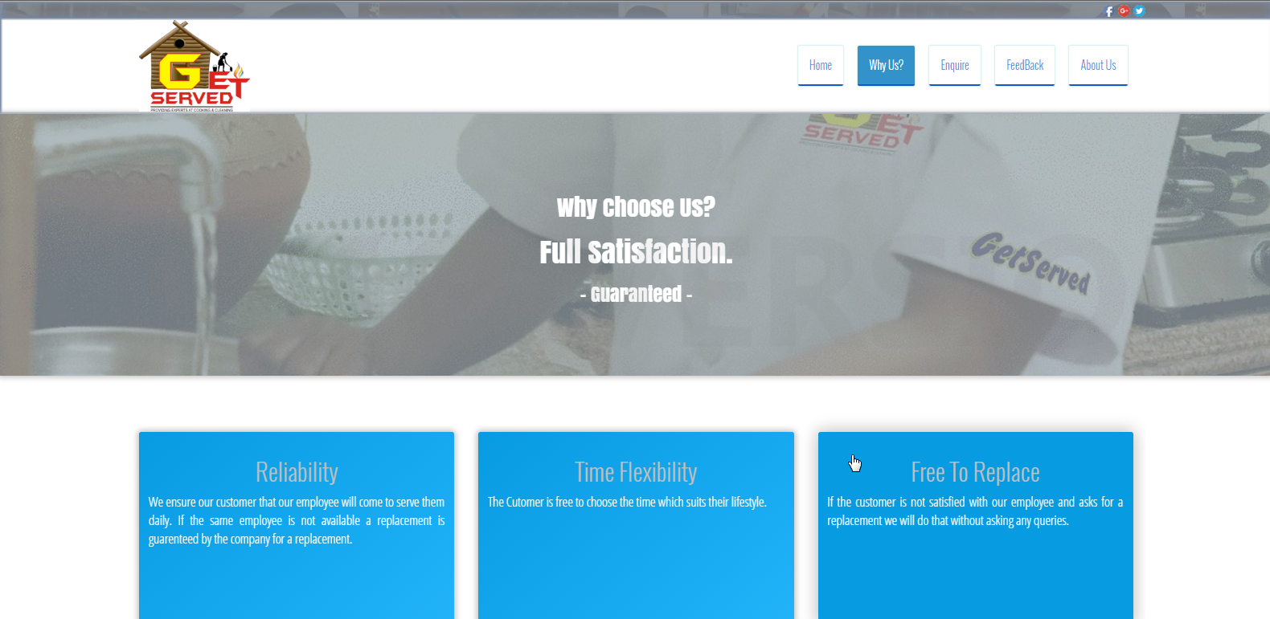

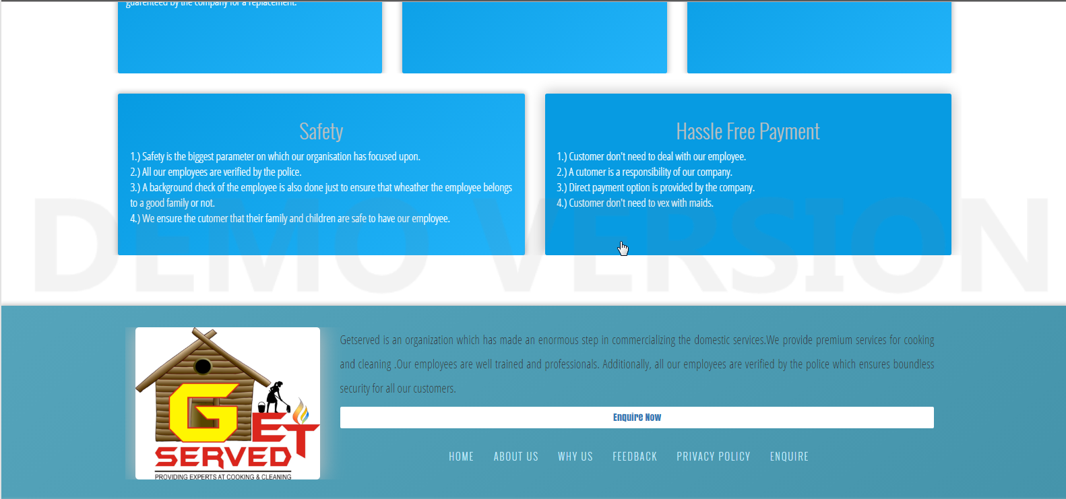

**whyus.php**

**<!DOCTYPE HTML>**

**<html>**

**<head>**

**<meta charset="utf-8" />**

**<meta name="viewport" content="width=device-width, initial-scale=1" />**

**<link rel="stylesheet" href="index.css" />**

**<link rel="stylesheet" href="bootstrap.css" />**

**<link rel="icon" type="image/gif/png" href="img/s_get-served.jpg" />**

**<title>Why Choose Us - Get Served | Ab koi tension nahi...</title>**

**</head>**

**<body>**

**<header>**

**<div id="Contact-Us_Subodh">**

**<div id="Inside-Contact-Us_Subodh">**

**<a href="#"><img src="Logos/logo_fb.png" height="15px" /></a>**

**<a href="#"><img src="Logos/logo_g+.png" height="15px" /></a>**

**<a href="#"><img src="Logos/logo_tw.png" height="15px" /></a>**

**</div>**

**</div><!-- Above Contact Us Strip Done -->**

**<div id="Nav-Div_Subodh">**

**<div style="margin-left: 10%;margin-right: 10%;height: 120px;">**

**<div class="col-md-5" style="height:120px;">**

**<a href="index.php"><img src="img/s_get-served.jpg" height="95%" style="margin-top: 3px;" /></a>**

**</div>**

**<div class="col-md-7" id="Nav-Div-Nav_Subodh">**

**<nav>**

**<a href="index.php" id="Nav-Home_Subodh"><div>Home</div></a>**

**<a href="whyus.php"><div style="background-color: #3392CA;color:white;" >Why Us?</div></a>**

**<a href="enquire.php"><div>Enquire</div></a>**

**<a href="feedback.php"><div>FeedBack</div></a>**

**<a href="aboutus.php"><div>About Us</div></a>**

**</nav>**

**</div>**

**</div>**

**</div>**

**</header>**

**<div data-stellar-background-ratio="0.5" class="Why-Us-Parallax_Subodh">**

**<div>**

**<div><h2 class="animated fadeInUp">Why Choose Us?</h2></div>**

**<div><h1 class="animated fadeInRight">Full Satisfaction.</h1></div>**

**<div><h3 class="animated fadeInLeft"> - Guaranteed - </h3></div>**

**</div>**

**</div><!-- parallax end -->**

**<div class="Why-Us-Content_Subodh">**

**<div style="overflow: hidden;">**

**<div class="col-md-4 animated fadeInLeft">**

**<div class="Why-Us-Blocks_Subodh">**

**<h2>Reliability</h2>**

**<p>**

**We ensure our customer that our employee will come to serve them daily. If the same employee is not available a replacement is guarenteed by the company for a replacement.**

**</p>**

**</div>**

**</div>**

**<div class="col-md-4 animated fadeInBig">**

**<div class="Why-Us-Blocks_Subodh">**

**<h2>Time Flexibility</h2>**

**<p>**

**The Cutomer is free to choose the time which suits their lifestyle.**

**</p>**

**</div>**

**</div>**

**<div class="col-md-4 animated fadeInRight">**

**<div class="Why-Us-Blocks_Subodh">**

**<h2>Free To Replace</h2>**

**<p>**

**If the customer is not satisfied with our employee and asks for a replacement we will do that without asking any queries.**

**</p>**

**</div>**

**</div>**

**</div>**

**<div style="overflow: hidden;">**

**<div class="col-md-6 animated fadeInUp">**

**<div class="Why-Us-Blocks_Subodh">**

**<h2>Safety</h2>**

**<p>1.) Safety is the biggest parameter on which our organisation has focused upon.<br>**

**2.) All our employees are verified by the police.<br>**

**3.) A background check of the employee is also done just to ensure that wheather the employee belongs to a good family or not.<br>**

**4.) We ensure the cutomer that their family and children are safe to have our employee.**

**</p>**

**</div>**

**</div>**

**<div class="col-md-6 animated fadeInUp">**

**<div class="Why-Us-Blocks_Subodh">**

**<h2>Hassle Free Payment</h2>**

**<p>1.) Customer don't need to deal with our employee.<br>**

**2.) A cutomer is a responsibility of our company.<br>**

**3.) Direct payment option is provided by the company.<br>**

**4.) Customer don't need to vex with maids.**

**</p>**

**</div>**

**</div>**

**</div>**

**</div>**

**<div id="Footer-Outer_Subodh">**

**<div id="Footer_Subodh">**

**<div>**

**<div class="col-md-3 Footer-Division_Subodh" style="text-align: center;">**

**<a href="index.php"><img src="img/s_get-served.jpg" width="100%" style="border-radius: 5px;box-shadow: 0px 0px 50px 2px silver ;" id="Footer-img_Subodh" /></a>**

**</div>**

**<div class="col-md-9 Footer-Division_Subodh">**

**<div>**

**<p>**

**Getserved is an organization which has made an enormous step in commercializing**

**the domestic services.We provide premium services for cooking and cleaning**

**.Our employees are well trained and professionals. Additionally, all our employees**

**are verified by the police which ensures boundless security for all our customers.**

**</p>**

**<a href="enquire.php">**

**<div class="Enquire-Button_Subodh">**

**Enquire Now**

**</div>**

**</a>**

**</div>**

**<ul>**

**<li><a href="index.php">HOME</a></li> &nbsp;&nbsp;&nbsp;&nbsp;**

**<li><a href="aboutus.php">ABOUT US</a></li> &nbsp;&nbsp;&nbsp;&nbsp;**

**<li><a href="whyus.php">WHY US</a></li> &nbsp;&nbsp;&nbsp;&nbsp;**

**<li><a href="feedback.php">FEEDBACK </a></li> &nbsp;&nbsp;&nbsp;&nbsp;**

**<li><a href="#">PRIVACY POLICY</a></li> &nbsp;&nbsp;&nbsp;&nbsp;**

**<li><a href="enquire.php">ENQUIRE</a></li> &nbsp;&nbsp;&nbsp;&nbsp;**

**</ul>**

**</div>**

**</div>**

**</div>**

**</div>**

**<script src="jquery.stellar.min.js"></script>**

**<script>**

**$.stellar();**

**</script>**

**</body>**

**</html>**

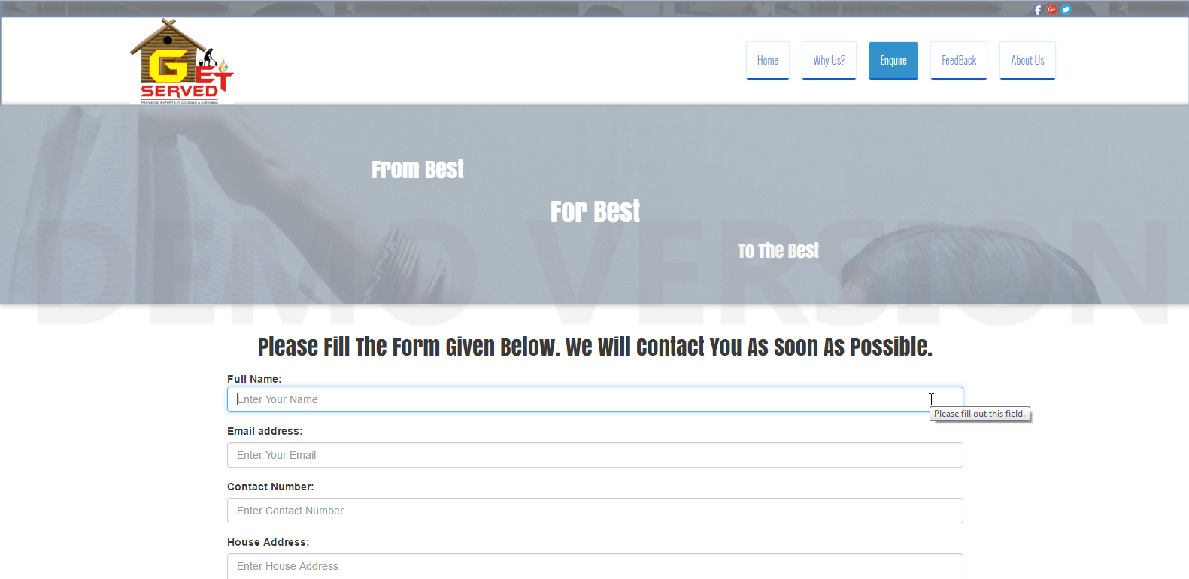

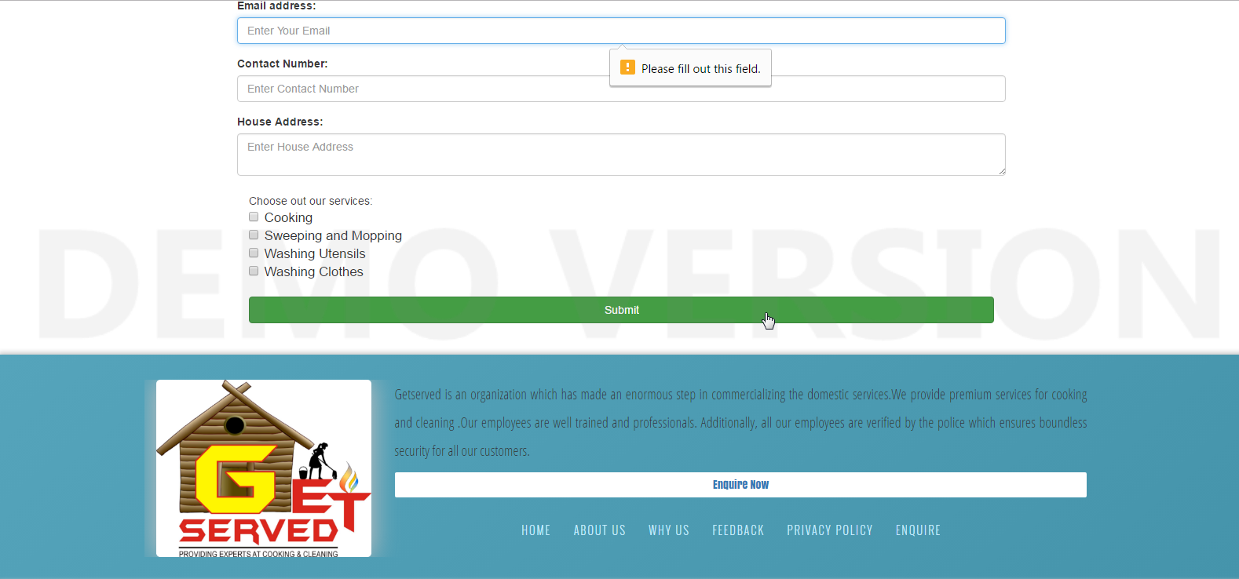

Enquire.php

<!DOCTYPE HTML>

<html>

<head>

<meta charset="utf-8" />

<meta name="viewport" content="width=device-width, initial-scale=1" />

<link rel="stylesheet" href="index.css" />

<link rel="stylesheet" href="bootstrap.css" />

<link rel="icon" type="image/gif/png" href="img/s_get-served.jpg" />

<title>About Us - Get Served | Ab koi tension nahi...</title>

</head>

<body>

<header>

<div id="Contact-Us_Subodh">

<div id="Inside-Contact-Us_Subodh">

<a href="#"><img src="Logos/logo_fb.png" height="15px" /></a>

<a href="#"><img src="Logos/logo_g+.png" height="15px" /></a>

<a href="#"><img src="Logos/logo_tw.png" height="15px" /></a>

</div>

</div><!-- Above Contact Us Strip Done -->

<div id="Nav-Div_Subodh">

<div style="margin-left: 10%;margin-right: 10%;height: 120px;">

<div class="col-md-5" style="height:120px;">

<a href="index.php"><img src="img/s_get-served.jpg" height="95%" style="margin-top: 3px;" /></a>

</div>

<div class="col-md-7" id="Nav-Div-Nav_Subodh">

<nav>

<a href="index.php" id="Nav-Home_Subodh"><div>Home</div></a>

<a href="whyus.php"><div>Why Us?</div></a>

<a href="#"><div style="background-color: #3392CA;color:white;" >Enquire</div></a>

<a href="feedback.php"><div>FeedBack</div></a>

<a href="aboutus.php"><div>About Us</div></a>

</nav>

</div>

</div>

</div>

</header>

<div data-stellar-background-ratio="0.5" class="About-Us-Parallax_Subodh">

<div style="margin-left: 30%;margin-right: 30%;">

<div style="text-align: left;"><h2 class="animated fadeInUp">From Best</h2></div>

<div style="text-align: center;"><h1 class="animated fadeInRight">For Best</h1></div>

<div style="text-align: right;"><h3 class="animated fadeInLeft"> To The Best </h3></div>

</div>

</div>

<!-- parallax end -->

<div style="margin-left: 20%; margin-right: 20%;margin-top: 40px;margin-bottom: 40px;">

<h2 class="about animated fadeInLeft"><p style="font-family: 'Anton';text-align: center">Please Fill The Form Given Below. We Will Contact You As Soon As Possible.</p></h2>

<div class="midbox sudee_backwhite">

<div class="enquire">

<div class="enquire_div">

<form class="form-horizontal" action="clientdetail.php" method="post" role="form" data-toggle="validator">

<div class="form-group">

<label for="usr" class="control-label animated fadeInRight">Full Name:</label>

<input type="name" class="form-control" id="name" name="name" placeholder="Enter Your Name" required />

</div>

<div class="form-group">

<label for="email" class="animated fadeInLeft">Email address:</label>

<input type="email" class="form-control" id="email" name="email" placeholder="Enter Your Email" required />

</div>

<div class="form-group">

<label for="number" class="animated fadeInRight">Contact Number:</label>

<input type="text" class="form-control" id="contact" name="contact" placeholder="Enter Contact Number" required />

</div>

<div class="form-group">

<label for="comment" class="animated fadeInLeft">House Address:</label>

<textarea row="3" class="form-control" id="address" name="address" placeholder="Enter House Address"></textarea>

</div>

<div class="checkbox">

<span class="animated fadeInRight">Choose out our services: </span><br />

<label style="width: 100%;font-size: 120%;"><input type="checkbox" id="services" name="services[]" value="cooking" /> Cooking </label><br />

<label style="width: 100%;font-size: 120%;"><input type="checkbox" id="services" name="services[]"value="swapping and mopping"/> Sweeping and Mopping </label><br />

<label style="width: 100%;font-size: 120%;"><input type="checkbox" id="services" name="services[]"value="washing utensile"/> Washing Utensils </label><br />

<label style="width: 100%;font-size: 120%;"><input type="checkbox"id="services" name="services[]" value="washing clothes"/> Washing Clothes </label><br />

</div><br />

<button type="submit" class="btn btn-success" style="text-align: center;width:100%;">Submit</button>

</form>

</div>

</div>

</div>

</div>

<div id="Footer-Outer_Subodh">

<div id="Footer_Subodh">

<div>

<div class="col-md-3 Footer-Division_Subodh" style="text-align: center;">

<a href="index.php"><img src="img/s_get-served.jpg" width="100%" style="border-radius: 5px;box-shadow: 0px 0px 50px 2px silver ;" id="Footer-img_Subodh" /></a>

</div>

<div class="col-md-9 Footer-Division_Subodh">

<div>

<p>

Getserved is an organization which has made an enormous step in commercializing

the domestic services.We provide premium services for cooking and cleaning

.Our employees are well trained and professionals. Additionally, all our employees

are verified by the police which ensures boundless security for all our customers.

</p>

<a href="#">

<div class="Enquire-Button_Subodh">

Enquire Now

</div>

</a>

</div>

<ul>

<li><a href="index.php">HOME</a></li> &nbsp;&nbsp;&nbsp;&nbsp;

<li><a href="aboutus.php">ABOUT US</a></li> &nbsp;&nbsp;&nbsp;&nbsp;

<li><a href="whyus.php">WHY US</a></li> &nbsp;&nbsp;&nbsp;&nbsp;

<li><a href="feedback.php">FEEDBACK </a></li> &nbsp;&nbsp;&nbsp;&nbsp;

<li><a href="#">PRIVACY POLICY</a></li> &nbsp;&nbsp;&nbsp;&nbsp;

<li><a href="#">ENQUIRE</a></li> &nbsp;&nbsp;&nbsp;&nbsp;

</ul>

</div>

</div>

</div>

</div>

<script src="jquery.stellar.min.js"></script>

<script>

$.stellar();

</script>

</body>

</html>

clientdetail.php

<!DOCTYPE HTML>

<html lang="en">

<head>

<meta charset="utf-8" />

<meta name="viewport" content="width=device-width, initial-scale=1" />

<link rel="stylesheet" href="index.css" />

<link rel="stylesheet" href="bootstrap.css" />

<link rel="icon" type="image/gif/png" href="img/s_get-served.jpg" />

<title>Get Served | Ab koi tension nahi....</title>

</head>

<body>

<?php

$name = $email = $number = $address = $services= '';

$name = $_POST['name'];

$email = $_POST['email'];

$contact = $_POST['contact'];

$address = $_POST['address'];

$services = $_POST['services'];

if( $_SERVER["REQUEST_METHOD"]=="POST")

{

if(!empty($_POST['services']))

{

foreach($_POST['services'] as $selected){

if($selected=="cooking"){

$s1=$selected;

}

if($selected=="swapping and mopping"){

$s2=$selected;

}

if($selected=="washing utensile"){

$s3=$selected;

}

if($selected=="washing clothes"){

$s4=$selected;

}

$body = "A user $name submitted the contact form: \n\n".

"Name: $name \n\n".

"Email: $email \n\n".

"Contact No.: $contact \n\n".

"Address: $address \n\n".

"Services: $s1 \n $s2 \n $s3 \n $s4; \n\n".

$to = "subodhlucky6262@gmail.com";

$subject = "Get Served - User enquiry";

}

}

mail($to,$subject,$body);}

?>

<div class="container-fluid logo" style="text-align: center;">

<div>

<img src="img/s_get-served.jpg" width="35%" />

</div><br />

<div>

<div>

<p style="box-shadow:0px 0px 1px 1px grey;background-color: #318FD5;color: white; border-radius: 3px;padding: 0.8%;line-height: 1.7;"> Thank You For Choosing Us.<br />

<i class="fa fa-smile-o" aria-hidden="true"></i> <a href="enquire.php" style="color: #D8EAF3;">Click here</a> to return back.

</div>

</div>

</div><br /><br /><br /><br />

</body>

</html>

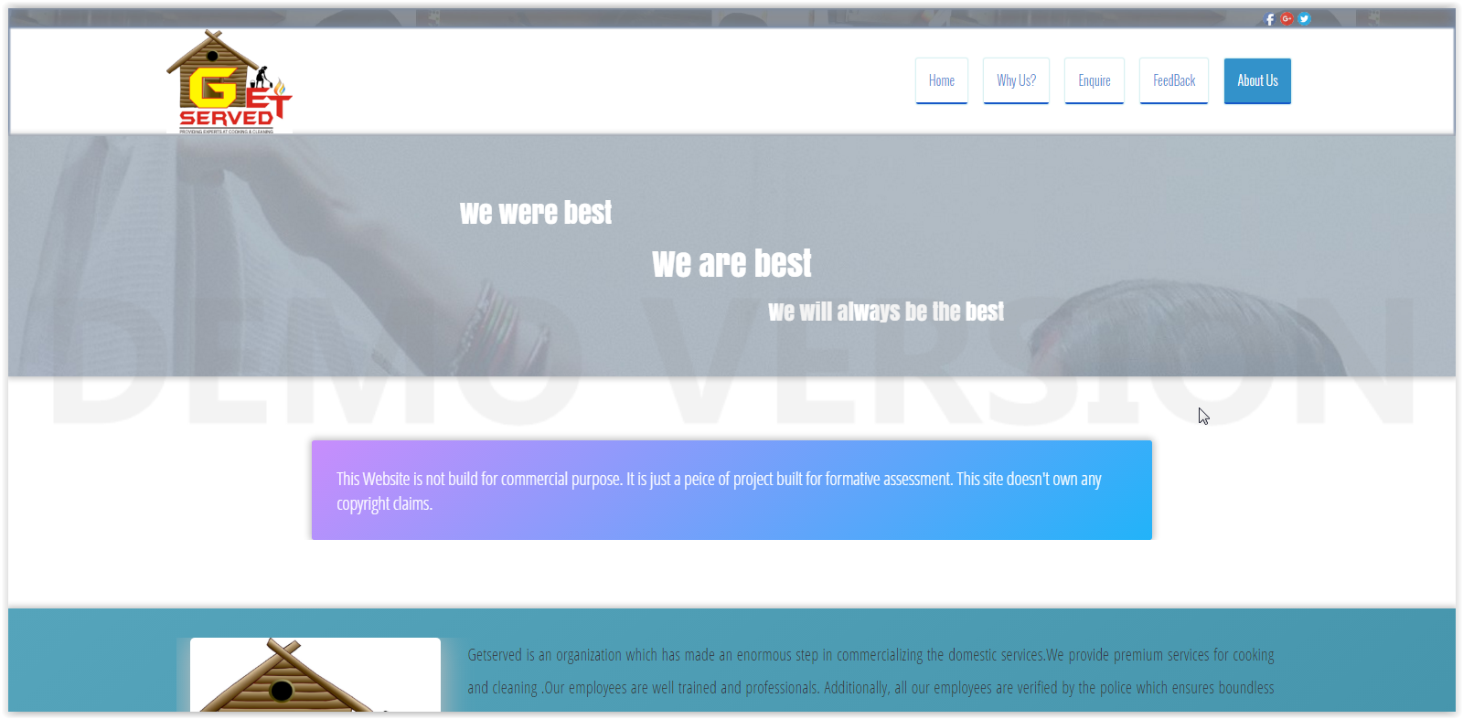

jquery.stellar.min.js

!function(a,b,c,d){function e(b,c){this.element=b,this.options=a.extend({},g,c),this._defaults=g,this._name=f,this.init()}var f="stellar",g={scrollProperty:"scroll",positionProperty:"position",horizontalScrolling:!0,verticalScrolling:!0,horizontalOffset:0,verticalOffset:0,responsive:!1,parallaxBackgrounds:!0,parallaxElements:!0,hideDistantElements:!0,hideElement:function(a){a.hide()},showElement:function(a){a.show()}},h={scroll:{getLeft:function(a){return a.scrollLeft()},setLeft:function(a,b){a.scrollLeft(b)},getTop:function(a){return a.scrollTop()},setTop:function(a,b){a.scrollTop(b)}},position:{getLeft:function(a){return-1*parseInt(a.css("left"),10)},getTop:function(a){return-1*parseInt(a.css("top"),10)}},margin:{getLeft:function(a){return-1*parseInt(a.css("margin-left"),10)},getTop:function(a){return-1*parseInt(a.css("margin-top"),10)}},transform:{getLeft:function(a){var b=getComputedStyle(a[0])[k];return"none"!==b?-1*parseInt(b.match(/(-?[0-9]+)/g)[4],10):0},getTop:function(a){var b=getComputedStyle(a[0])[k];return"none"!==b?-1*parseInt(b.match(/(-?[0-9]+)/g)[5],10):0}}},i={position:{setLeft:function(a,b){a.css("left",b)},setTop:function(a,b){a.css("top",b)}},transform:{setPosition:function(a,b,c,d,e){a[0].style[k]="translate3d("+(b-c)+"px, "+(d-e)+"px, 0)"}}},j=function(){var b,c=/^(Moz|Webkit|Khtml|O|ms|Icab)(?=[A-Z])/,d=a("script")[0].style,e="";for(b in d)if(c.test(b)){e=b.match(c)[0];break}return"WebkitOpacity"in d&&(e="Webkit"),"KhtmlOpacity"in d&&(e="Khtml"),function(a){return e+(e.length>0?a.charAt(0).toUpperCase()+a.slice(1):a)}}(),k=j("transform"),l=a("<div />",{style:"background:#fff"}).css("background-position-x")!==d,m=l?function(a,b,c){a.css({"background-position-x":b,"background-position-y":c})}:function(a,b,c){a.css("background-position",b+" "+c)},n=l?function(a){return[a.css("background-position-x"),a.css("background-position-y")]}:function(a){return a.css("background-position").split(" ")},o=b.requestAnimationFrame||b.webkitRequestAnimationFrame||b.mozRequestAnimationFrame||b.oRequestAnimationFrame||b.msRequestAnimationFrame||function(a){setTimeout(a,1e3/60)};e.prototype={init:function(){this.options.name=f+"_"+Math.floor(1e9*Math.random()),this._defineElements(),this._defineGetters(),this._defineSetters(),this._handleWindowLoadAndResize(),this._detectViewport(),this.refresh({firstLoad:!0}),"scroll"===this.options.scrollProperty?this._handleScrollEvent():this._startAnimationLoop()},_defineElements:function(){this.element===c.body&&(this.element=b),this.$scrollElement=a(this.element),this.$element=this.element===b?a("body"):this.$scrollElement,this.$viewportElement=this.options.viewportElement!==d?a(this.options.viewportElement):this.$scrollElement[0]===b||"scroll"===this.options.scrollProperty?this.$scrollElement:this.$scrollElement.parent()},_defineGetters:function(){var a=this,b=h[a.options.scrollProperty];this._getScrollLeft=function(){return b.getLeft(a.$scrollElement)},this._getScrollTop=function(){return b.getTop(a.$scrollElement)}},_defineSetters:function(){var b=this,c=h[b.options.scrollProperty],d=i[b.options.positionProperty],e=c.setLeft,f=c.setTop;this._setScrollLeft="function"==typeof e?function(a){e(b.$scrollElement,a)}:a.noop,this._setScrollTop="function"==typeof f?function(a){f(b.$scrollElement,a)}:a.noop,this._setPosition=d.setPosition||function(a,c,e,f,g){b.options.horizontalScrolling&&d.setLeft(a,c,e),b.options.verticalScrolling&&d.setTop(a,f,g)}},_handleWindowLoadAndResize:function(){var c=this,d=a(b);c.options.responsive&&d.bind("load."+this.name,function(){c.refresh()}),d.bind("resize."+this.name,function(){c._detectViewport(),c.options.responsive&&c.refresh()})},refresh:function(c){var d=this,e=d._getScrollLeft(),f=d._getScrollTop();c&&c.firstLoad||this._reset(),this._setScrollLeft(0),this._setScrollTop(0),this._setOffsets(),this._findParticles(),this._findBackgrounds(),c&&c.firstLoad&&/WebKit/.test(navigator.userAgent)&&a(b).load(function(){var a=d._getScrollLeft(),b=d._getScrollTop();d._setScrollLeft(a+1),d._setScrollTop(b+1),d._setScrollLeft(a),d._setScrollTop(b)}),this._setScrollLeft(e),this._setScrollTop(f)},_detectViewport:function(){var a=this.$viewportElement.offset(),b=null!==a&&a!==d;this.viewportWidth=this.$viewportElement.width(),this.viewportHeight=this.$viewportElement.height(),this.viewportOffsetTop=b?a.top:0,this.viewportOffsetLeft=b?a.left:0},_findParticles:function(){{var b=this;this._getScrollLeft(),this._getScrollTop()}if(this.particles!==d)for(var c=this.particles.length-1;c>=0;c--)this.particles[c].$element.data("stellar-elementIsActive",d);this.particles=[],this.options.parallaxElements&&this.$element.find("[data-stellar-ratio]").each(function(){var c,e,f,g,h,i,j,k,l,m=a(this),n=0,o=0,p=0,q=0;if(m.data("stellar-elementIsActive")){if(m.data("stellar-elementIsActive")!==this)return}else m.data("stellar-elementIsActive",this);b.options.showElement(m),m.data("stellar-startingLeft")?(m.css("left",m.data("stellar-startingLeft")),m.css("top",m.data("stellar-startingTop"))):(m.data("stellar-startingLeft",m.css("left")),m.data("stellar-startingTop",m.css("top"))),f=m.position().left,g=m.position().top,h="auto"===m.css("margin-left")?0:parseInt(m.css("margin-left"),10),i="auto"===m.css("margin-top")?0:parseInt(m.css("margin-top"),10),k=m.offset().left-h,l=m.offset().top-i,m.parents().each(function(){var b=a(this);return b.data("stellar-offset-parent")===!0?(n=p,o=q,j=b,!1):(p+=b.position().left,void(q+=b.position().top))}),c=m.data("stellar-horizontal-offset")!==d?m.data("stellar-horizontal-offset"):j!==d&&j.data("stellar-horizontal-offset")!==d?j.data("stellar-horizontal-offset"):b.horizontalOffset,e=m.data("stellar-vertical-offset")!==d?m.data("stellar-vertical-offset"):j!==d&&j.data("stellar-vertical-offset")!==d?j.data("stellar-vertical-offset"):b.verticalOffset,b.particles.push({$element:m,$offsetParent:j,isFixed:"fixed"===m.css("position"),horizontalOffset:c,verticalOffset:e,startingPositionLeft:f,startingPositionTop:g,startingOffsetLeft:k,startingOffsetTop:l,parentOffsetLeft:n,parentOffsetTop:o,stellarRatio:m.data("stellar-ratio")!==d?m.data("stellar-ratio"):1,width:m.outerWidth(!0),height:m.outerHeight(!0),isHidden:!1})})},_findBackgrounds:function(){var b,c=this,e=this._getScrollLeft(),f=this._getScrollTop();this.backgrounds=[],this.options.parallaxBackgrounds&&(b=this.$element.find("[data-stellar-background-ratio]"),this.$element.data("stellar-background-ratio")&&(b=b.add(this.$element)),b.each(function(){var b,g,h,i,j,k,l,o=a(this),p=n(o),q=0,r=0,s=0,t=0;if(o.data("stellar-backgroundIsActive")){if(o.data("stellar-backgroundIsActive")!==this)return}else o.data("stellar-backgroundIsActive",this);o.data("stellar-backgroundStartingLeft")?m(o,o.data("stellar-backgroundStartingLeft"),o.data("stellar-backgroundStartingTop")):(o.data("stellar-backgroundStartingLeft",p[0]),o.data("stellar-backgroundStartingTop",p[1])),h="auto"===o.css("margin-left")?0:parseInt(o.css("margin-left"),10),i="auto"===o.css("margin-top")?0:parseInt(o.css("margin-top"),10),j=o.offset().left-h-e,k=o.offset().top-i-f,o.parents().each(function(){var b=a(this);return b.data("stellar-offset-parent")===!0?(q=s,r=t,l=b,!1):(s+=b.position().left,void(t+=b.position().top))}),b=o.data("stellar-horizontal-offset")!==d?o.data("stellar-horizontal-offset"):l!==d&&l.data("stellar-horizontal-offset")!==d?l.data("stellar-horizontal-offset"):c.horizontalOffset,g=o.data("stellar-vertical-offset")!==d?o.data("stellar-vertical-offset"):l!==d&&l.data("stellar-vertical-offset")!==d?l.data("stellar-vertical-offset"):c.verticalOffset,c.backgrounds.push({$element:o,$offsetParent:l,isFixed:"fixed"===o.css("background-attachment"),horizontalOffset:b,verticalOffset:g,startingValueLeft:p[0],startingValueTop:p[1],startingBackgroundPositionLeft:isNaN(parseInt(p[0],10))?0:parseInt(p[0],10),startingBackgroundPositionTop:isNaN(parseInt(p[1],10))?0:parseInt(p[1],10),startingPositionLeft:o.position().left,startingPositionTop:o.position().top,startingOffsetLeft:j,startingOffsetTop:k,parentOffsetLeft:q,parentOffsetTop:r,stellarRatio:o.data("stellar-background-ratio")===d?1:o.data("stellar-background-ratio")})}))},_reset:function(){var a,b,c,d,e;for(e=this.particles.length-1;e>=0;e--)a=this.particles[e],b=a.$element.data("stellar-startingLeft"),c=a.$element.data("stellar-startingTop"),this._setPosition(a.$element,b,b,c,c),this.options.showElement(a.$element),a.$element.data("stellar-startingLeft",null).data("stellar-elementIsActive",null).data("stellar-backgroundIsActive",null);for(e=this.backgrounds.length-1;e>=0;e--)d=this.backgrounds[e],d.$element.data("stellar-backgroundStartingLeft",null).data("stellar-backgroundStartingTop",null),m(d.$element,d.startingValueLeft,d.startingValueTop)},destroy:function(){this._reset(),this.$scrollElement.unbind("resize."+this.name).unbind("scroll."+this.name),this._animationLoop=a.noop,a(b).unbind("load."+this.name).unbind("resize."+this.name)},_setOffsets:function(){var c=this,d=a(b);d.unbind("resize.horizontal-"+this.name).unbind("resize.vertical-"+this.name),"function"==typeof this.options.horizontalOffset?(this.horizontalOffset=this.options.horizontalOffset(),d.bind("resize.horizontal-"+this.name,function(){c.horizontalOffset=c.options.horizontalOffset()})):this.horizontalOffset=this.options.horizontalOffset,"function"==typeof this.options.verticalOffset?(this.verticalOffset=this.options.verticalOffset(),d.bind("resize.vertical-"+this.name,function(){c.verticalOffset=c.options.verticalOffset()})):this.verticalOffset=this.options.verticalOffset},_repositionElements:function(){var a,b,c,d,e,f,g,h,i,j,k=this._getScrollLeft(),l=this._getScrollTop(),n=!0,o=!0;if(this.currentScrollLeft!==k||this.currentScrollTop!==l||this.currentWidth!==this.viewportWidth||this.currentHeight!==this.viewportHeight){for(this.currentScrollLeft=k,this.currentScrollTop=l,this.currentWidth=this.viewportWidth,this.currentHeight=this.viewportHeight,j=this.particles.length-1;j>=0;j--)a=this.particles[j],b=a.isFixed?1:0,this.options.horizontalScrolling?(f=(k+a.horizontalOffset+this.viewportOffsetLeft+a.startingPositionLeft-a.startingOffsetLeft+a.parentOffsetLeft)*-(a.stellarRatio+b-1)+a.startingPositionLeft,h=f-a.startingPositionLeft+a.startingOffsetLeft):(f=a.startingPositionLeft,h=a.startingOffsetLeft),this.options.verticalScrolling?(g=(l+a.verticalOffset+this.viewportOffsetTop+a.startingPositionTop-a.startingOffsetTop+a.parentOffsetTop)*-(a.stellarRatio+b-1)+a.startingPositionTop,i=g-a.startingPositionTop+a.startingOffsetTop):(g=a.startingPositionTop,i=a.startingOffsetTop),this.options.hideDistantElements&&(o=!this.options.horizontalScrolling||h+a.width>(a.isFixed?0:k)&&h<(a.isFixed?0:k)+this.viewportWidth+this.viewportOffsetLeft,n=!this.options.verticalScrolling||i+a.height>(a.isFixed?0:l)&&i<(a.isFixed?0:l)+this.viewportHeight+this.viewportOffsetTop),o&&n?(a.isHidden&&(this.options.showElement(a.$element),a.isHidden=!1),this._setPosition(a.$element,f,a.startingPositionLeft,g,a.startingPositionTop)):a.isHidden||(this.options.hideElement(a.$element),a.isHidden=!0);for(j=this.backgrounds.length-1;j>=0;j--)c=this.backgrounds[j],b=c.isFixed?0:1,d=this.options.horizontalScrolling?(k+c.horizontalOffset-this.viewportOffsetLeft-c.startingOffsetLeft+c.parentOffsetLeft-c.startingBackgroundPositionLeft)*(b-c.stellarRatio)+"px":c.startingValueLeft,e=this.options.verticalScrolling?(l+c.verticalOffset-this.viewportOffsetTop-c.startingOffsetTop+c.parentOffsetTop-c.startingBackgroundPositionTop)*(b-c.stellarRatio)+"px":c.startingValueTop,m(c.$element,d,e)}},_handleScrollEvent:function(){var a=this,b=!1,c=function(){a._repositionElements(),b=!1},d=function(){b||(o(c),b=!0)};this.$scrollElement.bind("scroll."+this.name,d),d()},_startAnimationLoop:function(){var a=this;this._animationLoop=function(){o(a._animationLoop),a._repositionElements()},this._animationLoop()}},a.fn[f]=function(b){var c=arguments;return b===d||"object"==typeof b?this.each(function(){a.data(this,"plugin_"+f)||a.data(this,"plugin_"+f,new e(this,b))}):"string"==typeof b&&"_"!==b[0]&&"init"!==b?this.each(function(){var d=a.data(this,"plugin_"+f);d instanceof e&&"function"==typeof d[b]&&d[b].apply(d,Array.prototype.slice.call(c,1)),"destroy"===b&&a.data(this,"plugin_"+f,null)}):void 0},a[f]=function(){var c=a(b);return c.stellar.apply(c,Array.prototype.slice.call(arguments,0))},a[f].scrollProperty=h,a[f].positionProperty=i,b.Stellar=e}(jQuery,this,document);